CLASS TIMETABLE PLANNER
@CREATIVITY THINK (9483175986/7019689991)

ABSTRACT:
Class Timetable Planner is a web application designed to simplify academic scheduling for schools, colleges, and coaching centers. Users can create and review timetables, sync schedules with mobile calendars, receive reminders, and export or print schedules. Administrators manage classes, teachers, and schedules, send alerts and notices, and monitor analytics dashboards. Built using Django and Django Rest Framework for backend services and React with react-calendar for frontend scheduling, the system ensures efficient timetable creation, conflict-free scheduling, and enhanced communication between users and administrators..

INTRODUCTION OF THE PROJECT:
Educational institutions face challenges in creating conflict-free class schedules while ensuring timely communication with teachers and students. Class Timetable Planner provides a centralized platform where users can create, review, sync, and receive reminders for class schedules. Administrators can manage class assignments, teacher schedules, send alerts, and monitor performance via dashboards. The backend uses Django and Django Rest Framework for scheduling logic and data management, while the frontend uses React with react-calendar for intuitive timetable interaction. The system streamlines academic scheduling and improves overall institution efficiency..

PROJECT OBJECTIVES:

• Enable creation and management of class timetables
• Perform automated conflict checking during scheduling
• Allow synchronization with mobile calendars
• Provide reminders and notifications for upcoming classes
• Enable timetable export or printing
• Provide administrators with dashboards for analytics
• Facilitate efficient communication between users and administration

PROBLEM OF THE STATEMENT:
Scheduling classes manually in schools, colleges, and coaching centers often leads to conflicts, missed classes, and inefficient time management. Teachers and students may face difficulties tracking schedules, and administrators struggle to maintain updated timetables. Class Timetable Planner addresses these challenges by providing an automated web platform for creating and reviewing schedules, syncing with calendars, sending reminders, exporting or printing timetables, and offering administrators analytics dashboards for monitoring and optimization of academic schedules..

MOTIVATION OF THE PROJECT:
• Streamline class scheduling for educational institutions
• Reduce conflicts and overlapping classes
• Facilitate calendar synchronization for students and teachers
• Automate reminders and notifications for classes
• Provide administrators with a centralized dashboard for analytics

BLOCK DAIGRAM OF PROJECT:

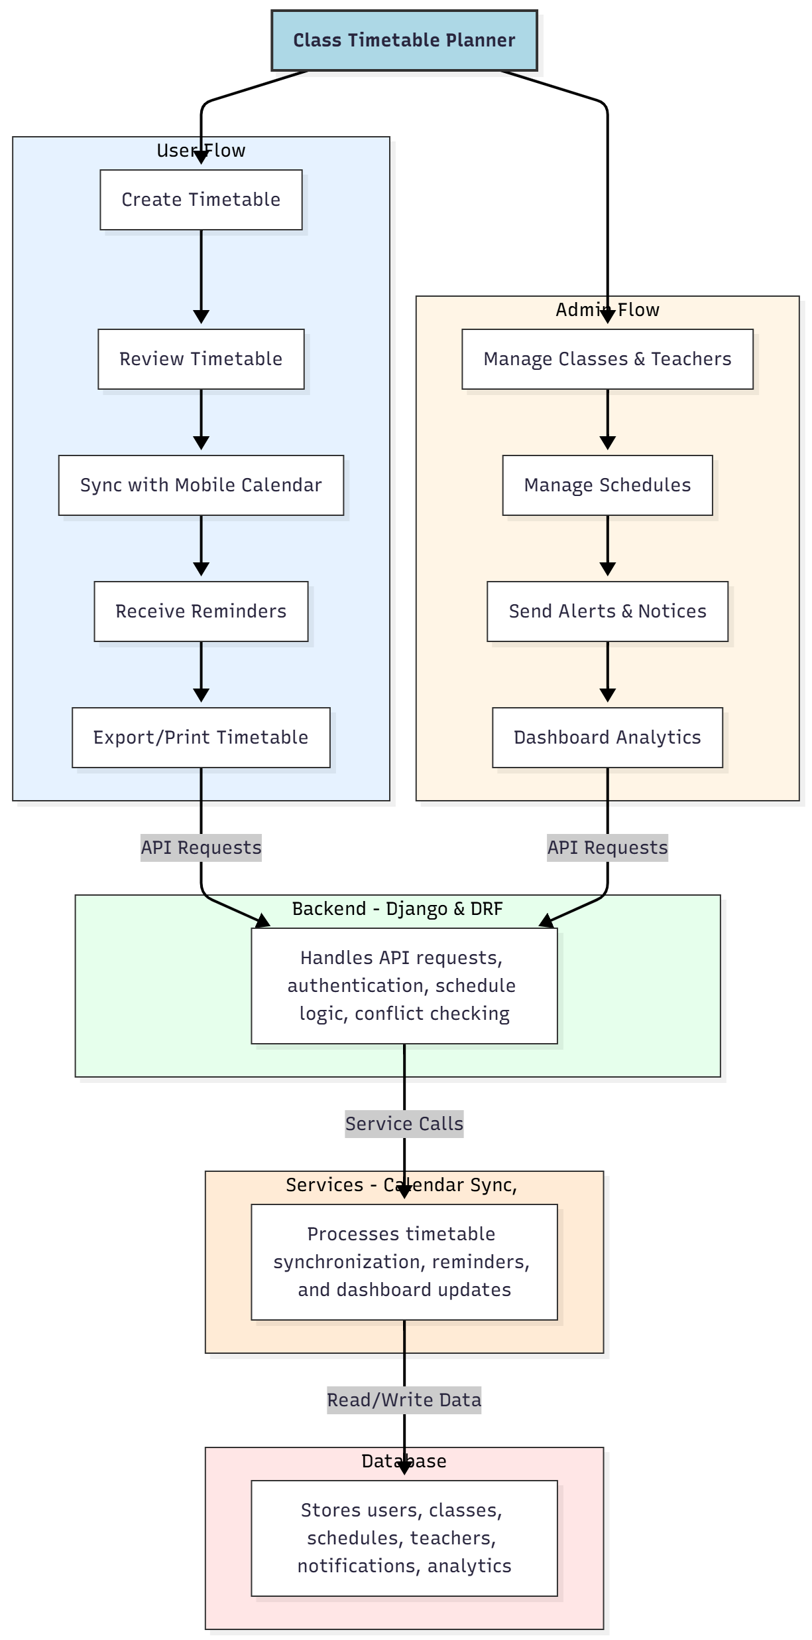

WORKING OF THE PROJECT:
Users create and review class timetables, synchronize schedules with mobile calendars, receive reminders, and export or print timetables. The backend handles API requests, authentication, schedule logic, and automated conflict checking. Services process calendar synchronization, reminders, and dashboard updates. Administrators manage classes, teachers, schedules, send alerts or notices, and monitor dashboards for analytics. This system ensures efficient scheduling, prevents conflicts, improves communication, and provides actionable insights for educational institutions..

SOFTWARE REQUIREMENT:
- Backend:
  - Python 3.x
  - Django
  - Django REST Framework
  - SQLite/PostgreSQL
- Frontend:
  - Node.js and npm
  - React.js
  - Axios
- Development Tools:
  - Visual Studio Code
  - Postman (for testing APIs)
  - Git/GitHub (for version control)
- Server/Deployment (Optional):
  - Gunicorn, Nginx, or Heroku/AWS for hosting

ADVANTAGES OF THE PROJECT:

• Automated timetable creation and conflict checking
• Mobile calendar synchronization for users
• Timely reminders and notifications
• Export and print options for schedules
• Administrator dashboards for analytics and monitoring
• Centralized management of classes and teachers
• Reduces scheduling errors and overlaps
• Enhances efficiency in educational institutions

APPLICATIONS OF THE PROJECT:
• School and college academic scheduling
• Coaching center timetable management
• Mobile calendar integration for students and teachers
• Automated reminders for classes
• Exportable and printable timetables
• Administrator monitoring dashboards
• Conflict-free class planning
• Efficient communication of schedules and notices

REFERENCES:

- Django REST Framework Documentation — Django Software Foundation. Django Documentation. Available: https://docs.djangoproject.com/
- Django REST Framework. DRF Documentation. Available: https://www.django-rest-framework.org/
- React. React Official Documentation. Available: https://reactjs.org/docs/getting-started.html
- Redux. Redux Documentation. Available: https://redux.js.org/introduction/getting-started
- PostgreSQL Global Development Group. PostgreSQL Documentation. Available: https://www.postgresql.org/docs/
- MySQL. MySQL Reference Manual. Available: https://dev.mysql.com/doc/
- Git. Git Documentation. Available: https://git-scm.com/doc
- Node.js. Node.js Documentation. Available: https://nodejs.org/en/docs/
- Axios. Axios Documentation. Available: https://axios-http.com/docs/intro
- Socket.io Documentation – https://socket.io/docs/

